Proceedings of the 35th National Conference on Mechanical Engineering of CSME: Guidelines for Extended Abstract Preparation

Author Name¹*, Author Name²
¹First Author’s English Affiliation
²Second Author’s English Affiliation
（MOSTXX-XXXX-XXXX-XX）
＊Email: Corresponding author’s email address

The 35th National Conference on Mechanical Engineering of CSME will be hosted by National Chung Cheng University. It will be held at Chiayi on November 30th and December 1st 2018. To assist participants in preparing their manuscripts for the conference proceedings, this Word template is provided. The length of each extended abstract should not exceed 2 pages. Manuscripts submitted should strictly follow the format of this template. Only manuscripts in the PDF format with no page numbers are acceptable and manuscripts should be submitted via the official website of the 35th National Conference of CSME, http://www.conf.tw/site/page.aspx?pid=901&sid=1229&lang=cht. The size of the PDF file should be less than 3 MB. 【Font Setting】The acceptable fonts are Times New Roman and Symbol. The title of the article should be in 14-point boldface type. Capitalize the first letter of nouns, pronouns, verbs, adjectives, and adverbs; do not capitalize articles, coordinate conjunctions, or prepositions (unless the title begins with such a word). Authors’ names and affiliations are to be centered beneath the title and in 12-point non-boldface type. Subtitles should be in 11-point and boldface. Type your main text in 10-point. All paragraphs should be indented by 0.9 cm. 【Margin Setting】The paper size is A4 (21 cm by 29.7 cm) with the following margins: upper 3 cm, lower 3 cm, left 2 cm, and right 2 cm. These margin settings should be followed under all circumstances. 【Figures and Tables】Figures and tables can be either placed at the end of paper as demonstrated in this template, or inserted within the running text. Captions of figures and tables should be in 10-point Times New Roman. The alignment of the caption can be either centered or justified, depending on the width of the figure. 【Equations】Equations should be centered aligned and numbered.
$\frac{∂^{2}φ}{∂x^{2}}+\frac{∂^{2}φ}{∂y^{2}}+\frac{∂^{2}φ}{∂z^{2}}=f\left(x,y,z\right)$ (1)
【References】List and number all bibliographical references at the end of your paper. When referenced in the text, enclose the citation number in square brackets. Formats are given below for your reference for journal paper[1], book[2], conference paper[3], thesis[4], technical report[5], patent[6], and webpage[7]. We are looking forward to seeing you at the conference. If you have any problem or question in preparing or submitting your manuscript, please feel free to contact us via the following e-mail address: csme2018contact@gmail.com.

Keywords: A list of 2-4 keywords should be included right beneath the abstract.

Acknowledgements
This work is funded by National Science Council under grant MOST-000-0000-E-000-MY3.

References
- C.C. Weng, M.C. Lin, and M.J. Huang, “A Waste Cold Recovery from the Exhausted Cryogenic Nitrogen by Using Thermoelectric Power Generator,” Energy, Vol. 103, pp. 385-396, 2016.
- 許源泉，鍛造學─理論與實習，第20-30頁，三民書局，台北，台灣，1997。
- 陳正文，邱聖麟，陳榮洪，蒲仁勇，林大惠，十六烷-水複合液滴的受熱行為與微爆現象，中國機械工程學會第二十二屆全國學術研討會論文集，燃燒學類，A7-001，中壢，台灣，2005。
- 翁健洲，以熱電發電器進行廢熱(冷)回收之分析研究，博士論文，國立臺灣大學機械工程學系，台北，台灣，2015。
- 黃美嬌，多晶及複合材料熱傳導特性非結構性網格蒙地卡羅模擬研究，NSC 100-2221-E-002-143-MY3，國科會結案報告，2014。
- M.C. Smith, A. Ritchie, V. Caron, D.A. Kramer, Method for forming a cooling jacket for an electric motor, US patent 8,161,643 B2, 2012.
- http://www.me.ntu.edu.tw/CSME2016/。

Figures and Tables
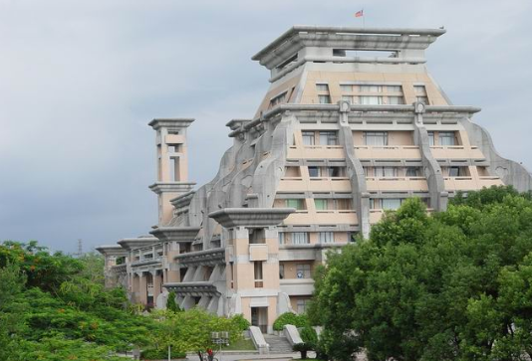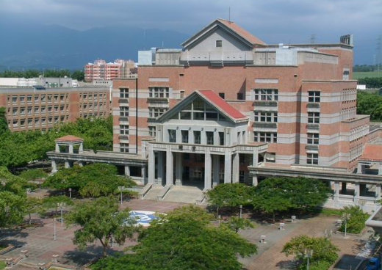
Fig. 1 The 35th National Conference on Mechanical Engineering of CSME will be held at Chiayi on November 30th and December 1st 2018.

Table 1 Important dates for the 35th National Conference on Mechanical Engineering of CSME.
Draft Paper Submission Deadline | 2018.09.15
Notification of Acceptance | 2018.10.15
Final Paper Submission Deadline | 2018.10.22
Online Payment Deadline | 2018.11.01

